# Instruction Set of 8086

Instructions are classified on the basis of functions they perform. They are categorized into the following main types:

Data Transfer instruction

All the instructions which perform data movement come under this category. The source data may be a register, memory location, port etc. the destination may be a register, memory location or port. The following instructions come under this category:

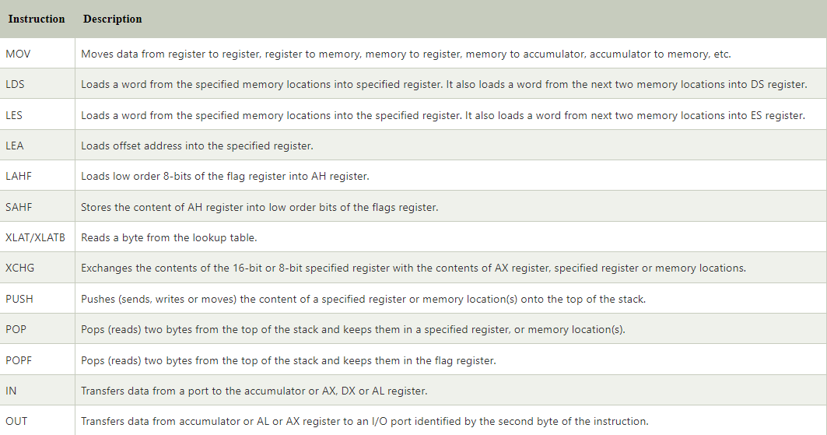

## Arithmetic Instructions

Instructions of this group perform addition, subtraction, multiplication, division, increment, decrement, comparison, ASCII and decimal adjustment etc.

**The following instructions come under this category:**

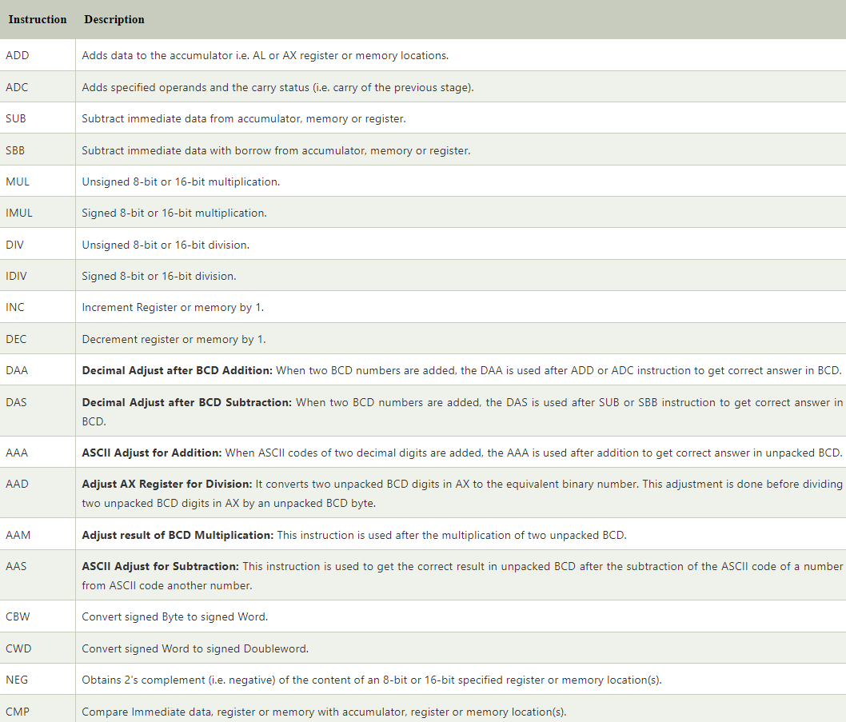

## Logical Instructions

Instruction of this group perform logical AND, OR, XOR, NOT and TEST operations. **The following instructions come under this category:**

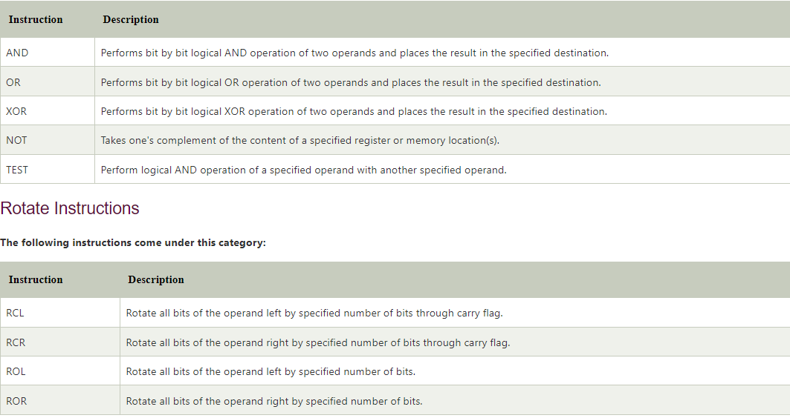

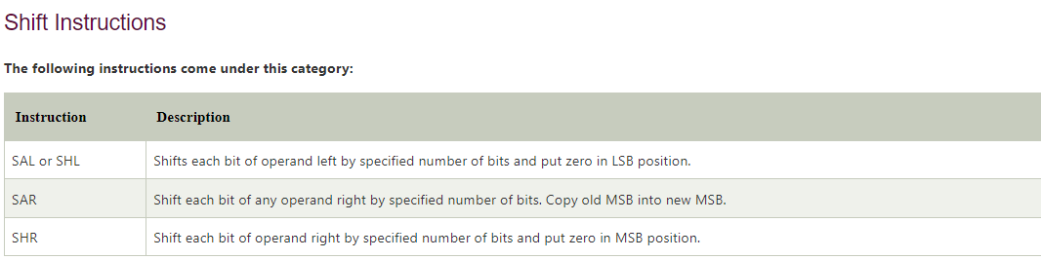

## Branch Instructions

It is also called program execution transfer instruction. Instructions of this group transfer program execution from the normal sequence of instructions to the specified destination or target. The following instructions come under this category:

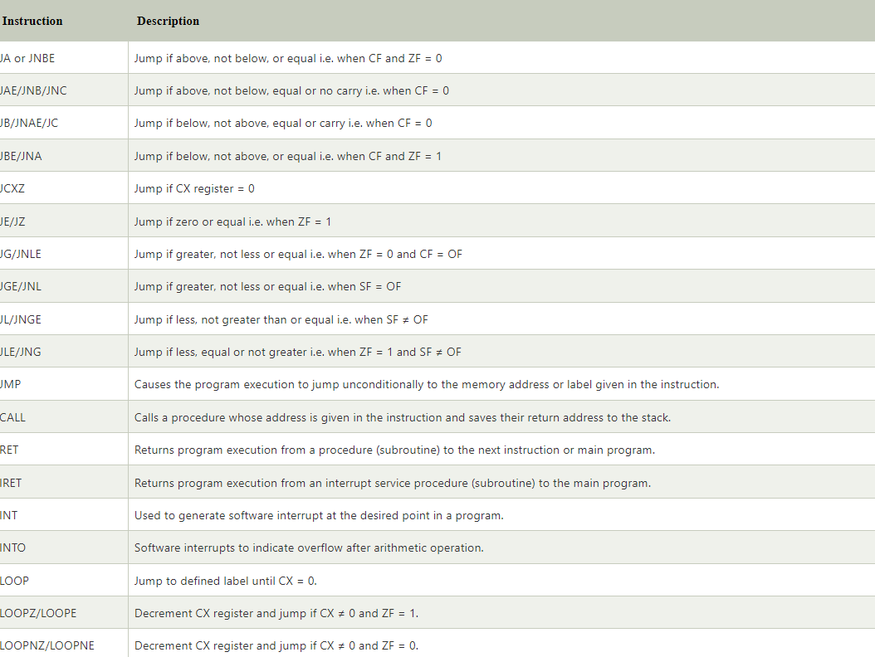

Here, CF = Carry Flag  
ZF = Zero Flag  
OF = Overflow Flag  
SF = Sign Flag  
CX = Register

## Flag Manipulation and Processor Control Instructions

Instructions of this instruction set are related to flag manipulation and machine control. The following instructions come under this category:

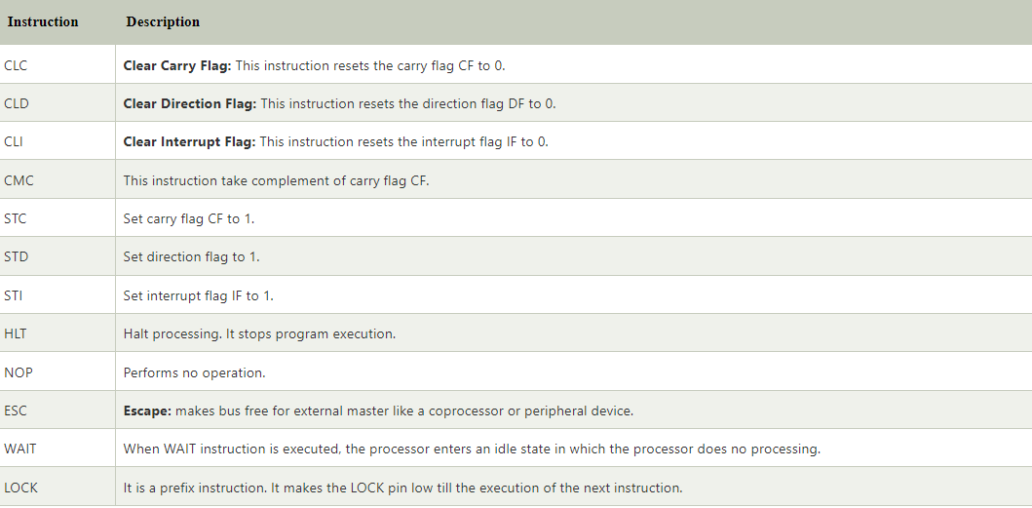

## String Instructions

String is series of bytes or series of words stored in sequential memory locations. The 8086 provides some instructions which handle string operations such as string movement, comparison, scan, load and store.

**The following instructions come under this category:**

